Issue 1: To resolve firewall blockage issue while sharing the drive:

R1: Disconnect VPN if it is connected

Issue 2 : Docker must be running in order to avoid this issue. First run the docker.exe from the desktop. If that does not resolve the error, then ‘restart’ docker (look at the second image)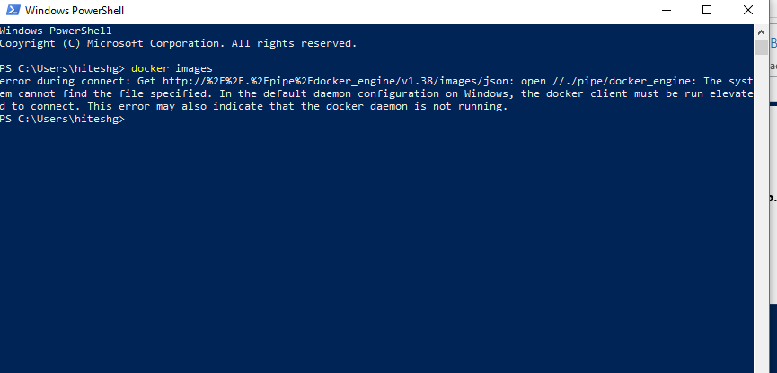

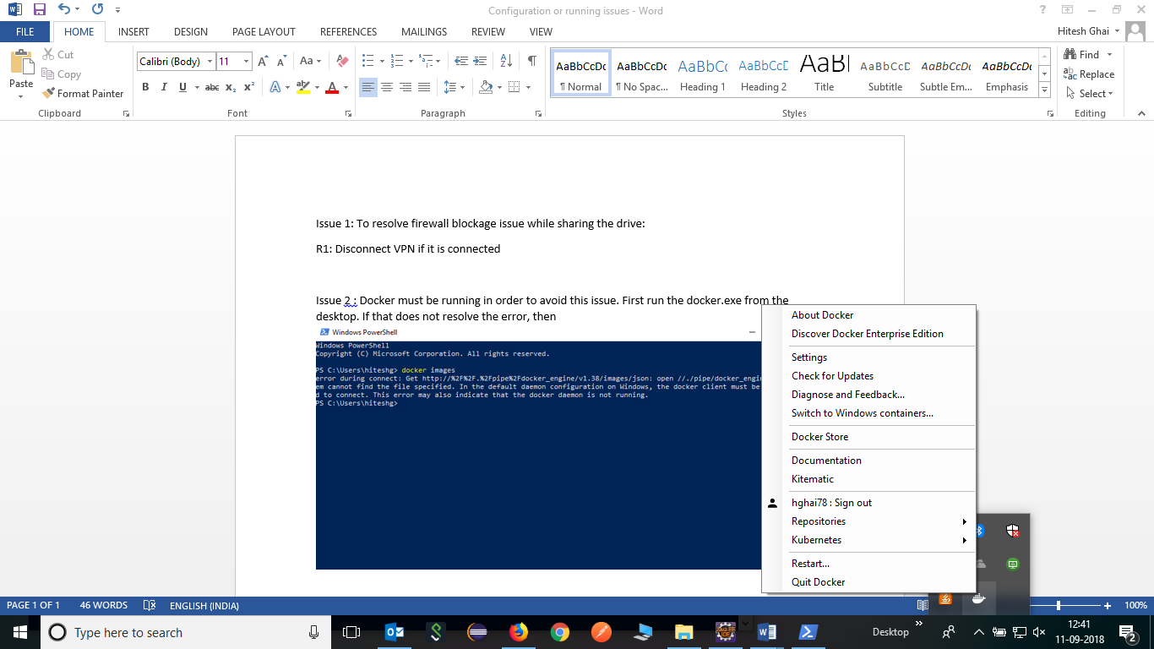

If restart docker did not resolve the error then follow the following solution. HG: after following the following solution, docker did not show any error.

